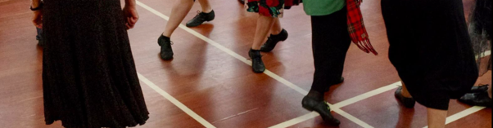
Wellington Region Class
Basic Skills 2021
When:
Tuesday evening classes:
13 & 27 July, 10 & 24 August, 7 September 2021
7.30 – 9.30pm

Where:
St David’s Multicultural Hall
Elizabeth Street
Petone

Tutor: Jeanette Watson

Cost: $40 for all 5 classes

Who:
For all dancers who wish to solidify their knowledge of steps and formations.
For those who attended the Basics 1 course this will be a continuation.

To register online click here
Or go to www.wellingtonscd.org.nz for more information

How do I find it?
