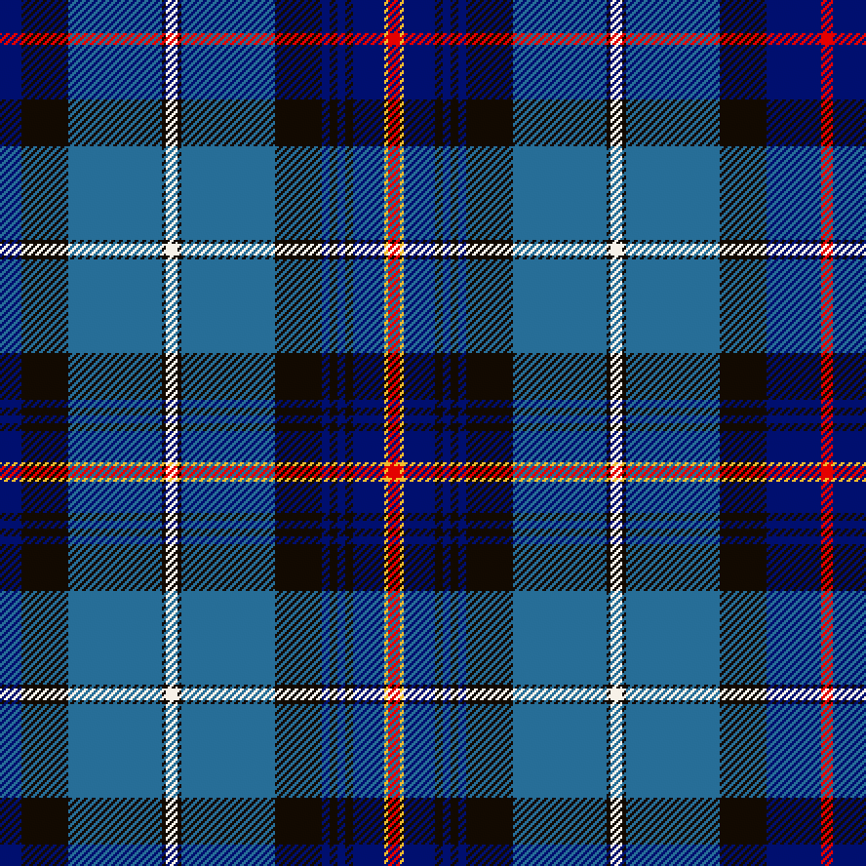
Dance Scottish Wellington
Hogmanay 2021-2022
Dance Scottish Wellington
Hogmanay 2020-2021

31st December 2021, 8pm

Knox Church Hall, High Street, Lower Hutt

RSCDS $18 / Non RSCDS $20 / Juniors & Spectators $10 / Family $50
Plus a small disposable plate of cold finger food (no heating available)

Music by Aileen Logie & her Band

Due to Covid-19 and to avoid queues on the night, pre-registration and payment is requested. Register online – click here. Details of how to pay are on the registration form.
The pre-Hogmanay class at Epuni Hall on the 27th December (between 7:30-9:00) will only run if there at 24 attendees or more
PROGRAMME
Easy Peasy Rights & Lefts J | Hooper’s Jig J
The Captain’s House R | The Pawling Porch R
The Byron Strathspey S | The Water of Leith S *
Ecclefechan Feline J | Violynne R
Trip to Timber Ridge R | The Aviator J *
Fair Donald S | The Shores of Solway S
The Amateur Epidemiologist R * | Orpington Caledonians R
Yan Tan Tethera J
The Flower of Glasgow S * | CEREMONY
Scott Meikle R
St Bernard’s Waltz W | Eightsome/Thirtytwosome Reel R *
SUPPER | Culla Bay S *
 | De’il Amang the Tailors R
Some dances will be walked. *Dances are more challenging

