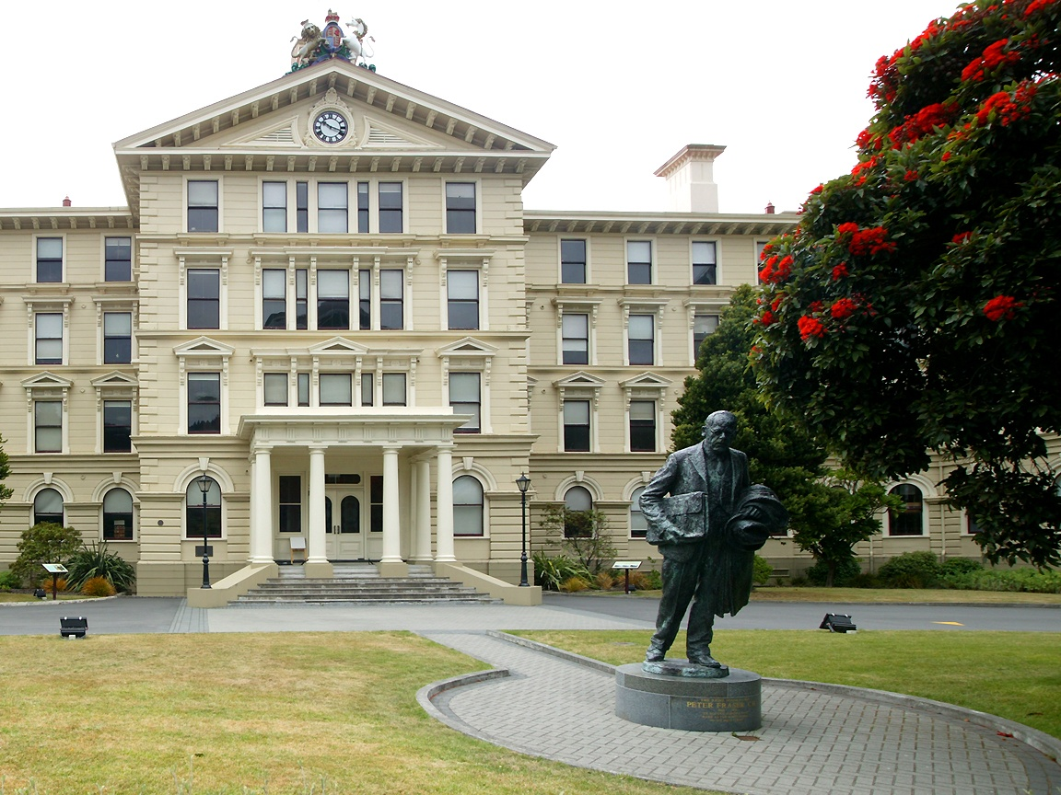

**Summer Dancing 2022**

Old Government Building  
55 Lambton Quay, Wellington

Covid Passports Required

Tuesdays: 7.30pm – 9pm  
18th and 25th Jan, 1st and 8th Feb

On the front lawn

(Wet weather venue to be confirmed in Jan – Check www.wellingtonscd.org.nz for updates)

Gold Coin Donation

7.30pm

Fun informal dancing